

**Database Management Project**

Final Report

Project Name: SPMS V2.0

**Group 01**

**Contributors:**

|  |  |
| --- | --- |
| **Name :** | **ID:** |
| Udipta Mazumder | 1710138 |
| Tamima Sigma | 1630436 |
| Hasan Ahmed | 1610266 |
| Misbah Ahmed | 1510998 |
| Md. Mahmud Hassan Rabby | 1731609 |
| Md Rakib Hossain | 1731400 |
| Rakibul Hasan Rajib | 1921834 |

Table of Contents:

CHAPTER 1.0 - INTRODUCTION: 3

1.1 BACKGROUND OF THE ORGANIZATION- IUB: 4

1.2 BACKGROUND OF THE PROJECT SPSM 2.0: 5

1.3 OBJECTIVE OF THE PROJECT SPSM 2.0: 5

1.4 SCOPE OF THE PROJECT: 6

CHAPTER 2.0 - REQUIREMENT ANALYSIS: 7

2.1 RICH PICTURE – EXISTING BUSINESS SYSTEM: 8

2.2 SIX ELEMENTS ANALYSIS - EXISTING BUSINESS SYSTEM: 10

2.3 PROCESS MODEL – EXISTING BUSINESS SYSTEM: 20

2.4 PROBLEM ANALYSIS – EXISTING BUSINESS SYSTEM: 23

2.5 RICH PICTURE - PROPOSED SYSTEM: 27

2.6 SIX ELEMENTS ANALYSIS – PROPOSED SYSTEM : 30

2.7 PROCESS MODEL - PROPOSED SYSTEM: 50

Chapter-3.0 LOGICAL SYSTEM DESIGN: 58

3.1 BUSINESS RULE [ SPMS V2.0 ]: 58

3.2 ENTITY RELATIONSHIP DIAGRAM: 60

3.3 ENTITY RELATIONSHIP DIAGRAM TO RELATIONAL SCHEMA: 61

3.4 NORMALIZATION: 62

3.6 DATA DICTIONARY: 65

# **CHAPTER 1.0 - INTRODUCTION:**

The Independent University, Bangladesh (IUB) has robust and versatile schools - notably consisting of following:

● Business & Entrepreneurship

● Engineering, Technology & Sciences

● Environment and Life Sciences

● Liberal Arts & Social Sciences

● Pharmacy and Public Health.

The university has been an active participant in the growth of the education sector in Bangladesh and produced capable and knowledgeable scholars contributing both here and abroad. [1]

IUB has achieved this through working closely with relevant government education institutions and organizations such as the University Grants Commission (UGC), Ministry of Education, and other necessary institutes for each of the schools, regularly updating its curriculums and putting in a system to monitor student performance based on a quantified approach between course curriculum and standards set by UGC and the Bangladesh government and constantly tracking student performance for every semester – mainly, using Outcome-Based Education (OBE) for monitoring performance and setting university curriculum. [1]

The focus of this report is to study the current student performance monitoring system that IUB uses, do the required analysis of its processes, and propose a new and better improved system that reduces error, makes analysis of data and report generation easier by all vested quarters and produce/show valuable information needed for IUB and its collaborators in making necessary improvements in academia to produce better scholars. The first part focuses on the details of the organization in question and the project that we have undertaken for it. The second part focuses

on the existing system and its shortcomings and an introduction of the proposed system that we plan to replace the existing system with. The third and fourth will be heavily technical and focus on how we plan to bring the proposed system into being.

During our research into the existing system for student performance monitoring we found many areas where valuable changes could be made to make each process of monitoring student performance faster, make communication between necessary stakeholders easier, take away chances for errors and data duplication, and most importantly make it easier for all stakeholders to easily surf through large datasets to get meaningful information to their requirement.

As we go through this report, we will dig deeper into how the current student performance monitoring system operates, the business processes involved, where there are concerns and issues related to data management, and how we can make a better system to address these issues for fixing and improvement.

# 1.1 BACKGROUND OF THE ORGANIZATION- IUB:

Independent University, Bangladesh (IUB), established in 1993, is one of the oldest private universities in Bangladesh, currently has more than an estimation of 7,048 undergraduate and graduate students and over 10,455 alumni. This student population is mostly predicted to grow at 10% annually. [2]

IUB, over-time, has shown remarkable outcomes in producing graduates with marketable skills only because of staying disciplined and up to date with the on-going curriculum and progress system. Dedicating attention towards IUB’s Departments, and more specifically focusing the Department of Computer Science and Electrical science into a well-funded research hub running several research projects. IUB is also committed to curve potential graduates of international standard who are mainly equipped to provide new leadership to the national economy through skilled employment, entrepreneurship and/or applied research. This is successful due to the

overwhelming support of the Bangladesh Government and the UGC for IUB to be able to create state-of-the-art lab facilities in their department. It is because of IUB’s approach to academics as an “Application Oriented Learning” philosophy that “not only teaches students the fundamental principles of learning, situation -handling, and have better overall perception by providing them with hands-on training sessions.” [3]

Continuously growing it’s lab facilities and flourishing on its curriculum according to current market economic demands, the SECS and the Department of Computer Science and Engineering at IUB has constantly worked with IEB, UGC and the Ministry of Education to track their students’ overall performance under specific periods by quantifying specific courses and its relating assessments into measurable trackers to gain valuable insights for improvement of students over the years as a student in a certain department.

These processes and criteria credentials courses are ultimately set by IEB along with relevant government potentials to set the bar for up-coming graduating engineers from top universities in Bangladesh. These set of standards come in the form of Program Educational Objectives (PEO) and Program Learning Outcomes (PLO) [1] for specific departments in an Accreditation Manual which are mapped to specific courses by relevant Course Instructors and Co-Ordinator’s. This allows the Department of CSE at IUB, SECS, IEB and all other relevant stakeholders to have a calculating assessment of the current state-of-affairs and the performance of each student under each course for every semester. This will also allow users to track performance of faculties, courses, departments and schools and provides valuable insight for making necessary improvements.

# 1.2 BACKGROUND OF THE PROJECT SPSM 2.0:

Measuring the output of students, faculties, departments, and their respective courses in order to measure their productivity in regard to the outcome relevance of the course activities. Basically, to provide a range of tools and data intended to help universities and education authorities such as IEB, UGC, as well as other stakeholders to evaluate the performance of students and inform strategies for improvements. Developing a national framework for Outcome-Based Education while at the same time leaving considerable freedom to universities in implementing local approaches.

# 1.3 OBJECTIVE OF THE PROJECT SPSM 2.0**:**

The SPMS 2.0 system monitors and summarizes the performances of the stakeholders - students, faculties, schools, and departments through the database of the assessments. For evaluation purposes the system would be able to store individual assessment marks (midterm, quizzes, assignment, projects, presentations and so on). As well as the marks of those assessments with respect to their Course Outcomes (CO) and Program Learning Outcomes (PLO) accordingly in the database of the system to observe the outcome and performance of the student’s faculties, schools, and departments. SDASDASDSDAADASDASDASDADDA

The students being the primary stakeholder, would be able to statistically directly monitor the overall performance to their satisfaction of certain course objectives. Hence based on their performances and faculty evaluation the higher stakeholders (Head of department and Admin) can understand and manage the degree in comparison to which different course outcomes targets and their achievements are being understood by the student, department, school, and university body as a whole. SPSMS 2.0 also monitors the impact of policies against overall administrative goals and targets by the system. The system’s main target is to monitor the whole university activities through the database and produce analytics for the Head of Department, Faculty, School, Students, and their Courses in a given period of time (yearly and semester wise).

# 1.4 SCOPE OF THE PROJECT:

We did a complete analysis of the existing system and found out places in the business processes which can cause severe lapses in time and communication, which we will discuss in the next chapter.

Our solution is to create a Web application, called SPMS 2.0 (Student Performance Monitoring System 2.0), using a Relational Database Management System (RDMS) to store, edit, add, and update necessary data for monitoring student performance and producing and storing related OBE data, reports, and documents.

We produced potential users for the web based SPMS 2.0 system and speculated how they would be using the system and the necessary information and data they would need access to. Since the problems can arise from many points of all business processes, we will make custom user interfaces and login capabilities for all stakeholders who will also be the users of this system.

Since we use a (RDBMS) for data storage, retrieving necessary files, tabular data, page layouts and reports becomes incredibly easy and allows us to interact with the necessary data to occur real-time. We also create interfaces for all users to easily access these data and use them to generate and download reports.

We build an interface for faculties to be able to collaborate with each other on developing course outlines,coursereports, marksheets, assessments, mapping assessments to CO’s and PLOs for PLO achievements, and record assessments of students throughout the semester for all their courses.

Students, the IUB leadership team and government agencies can also access the systems for drawing conclusions. Data will also be protected, and each stakeholder will be shown only that data which is relevant to them, respectively.

# **CHAPTER 2.0 - REQUIREMENT ANALYSIS:**

The Requirement Analysis is the means of using industry tools, methods, and standards, to research and visualize the current system and the processes that go into the business operation of a certain organization. “Requirements Analysis is the process of determining what the database is to be used for. It involves interviews with user groups and other stakeholders to identify what functionality they require from the database, what kinds of data they wish to process and the most frequently performed operations.” [4]

By doing this we can see each stakeholder and how they interact with each other. We use simple notations and symbols to give anyone the idea of how a business process works and dissect it accordingly.

As we will see, this process of analyzing lets us find out apparent and not so apparent problems with an existing system of monitoring student performance that is manual and depends on involving third party actors and stakeholders causing errors in the system.

# 

# 2.1 RICH PICTURE – EXISTING BUSINESS SYSTEM:

A Rich Picture is a way to explore, acknowledge and define a business process and express it through diagrams to create a preliminary mental model. A rich picture helps to open discussion and come to a broad, shared understanding of a situation. [5]The finished rich picture could be of value to other stakeholders of the problems in an existing system, but also allows them to capture

many different facets of the situation. Rich pictures concentrate on both the structure and the processes of a given situation. [6]

The Rich Picture Analysis also takes in to account the following:

* Structures
* Processes
* Climate
* People
* Issues expressed by people.
* Conflict

As we can see, this rich picture was prepared keeping exactly those things in mind.

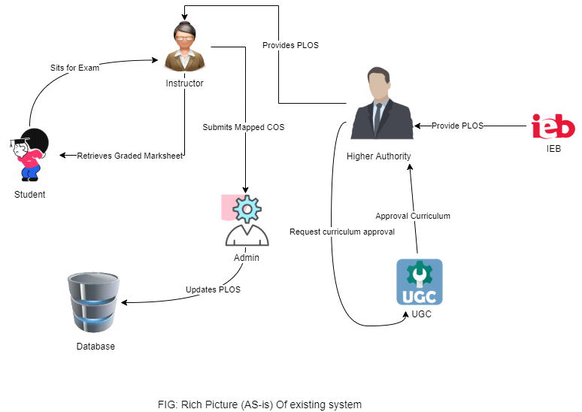

Figure 1.0: Rich Picture of Existing System to Monitor SPMS.

**The Rich Picture Analysis shows us that we have the following types of stakeholders:**

* IEB/UGC/Ministry of Education
* VC/Board of Trustees
* Head of Department/Dean of School
* Department (working under Head of Department/Dean of School)
* Faculty/Course Coordinators
* Registrar’s Office
* Admin (working under Registrar’s Office)
* Students

**We can also identify three separate storage systems or facilities, namely:**

* The Department Storage
* The Registrar’s Office Storage
* IRAS

**From this Rich Picture we have drawn out 7 process that are key to monitoring student performance and improving curriculum. The processes are as follows:**

* Map Course Outcomes (COs) to Program Learning Outcomes (PLOs).
* Record Student Assessment Data.
* View Assessment Reports over a given time-period for inspection and analysis of student performance trend.
* Produce OBE Marksheet & Course Assessment Report.
* Create student/faculty account and enter/customize necessary data.
* View Records OBE Marksheets, Course
* Request for review and change of grades.

# 2.2 SIX ELEMENTS ANALYSIS - EXISTING BUSINESS SYSTEM**:**

The Six Elements Analysis provides a detailed description of the role of each element in each process. It is clear from the table below that Human entities dominate all key functions of this system (especially in the most critical two processes- mapping course outcomes and viewing document related to them.) For example, the current system is heavily dependent on manually processed and handled hardcopy databases. Thus, there is a significantly long chain of waiting

between interdependent procedures before the Human elements can fulfill their end of the bargain in the process.

|  |  |  |  |  |  |  |
| --- | --- | --- | --- | --- | --- | --- |
| **Process** | **System Roles** | | | | | |
| **Human** | **Non-Comp**  **Hardware** | **Computing**  **Hardware** | **Software** | **Database** | **Network & communication** |
| **Map Course**  **Outcomes (COs)**  **to Program**  **Learning**  **Outcomes (PLOs)** | **IEB/UGC/ Ministry of**  **Education:**  1. Send Accreditation Manual  with PLOs defined to Heads of  Department/Dean of School.  **Head of Department / Dean of**  **School:**  1. Receive Accreditation Manual  from IEB.  2. Send the Accreditation manual  to Department Staff.  3. Direct Department Staff to tell  Course Instructors and  Coordinators to design Course  Outline and Course Assessment  Reports.  **Department:**  1. Send Course Instructors the  Accreditation Manual with  Defined PLOs.  **Course Instructor:**  1. List course content.  2. List COs.  3. Map Course Content to **Course**  **Outcomes (COs).**  4. Map COs to PLOs.  5. Map COs to specific questions  of Mid-term, Final Exams  questions and Project Work.  6. Starting to design course  assessment report using course  outline, Course Content and Co. | **Pen and paper:**  1. Is used for noting  down intermediate  Brainstorming ideas.  **Board and marker:**  1. Is used for noting  down intermediate  Brainstorming ideas. | **Computer:**  1. Course  Coordinators use  computers to make  softcopies of Course  Outcomes (COs) of  the specific courses  They are experts in.  **Printer:**  1. To print out  hardcopies of Course  Outcomes (COs). | **MS Word:**  1. Course  Coordinators use  MS Word to make  a detailed course  outline and Course  Assessment  Reports with  Course Outcomes  (COs) mapping to  Program Learning  Outcomes (PLOs).  **Excel Sheet:**  1. Excel Sheet is  used by Course.  Coordinators to  map specific  questions in the  Midterm, Final  exams and Project  work to specific  Course Outcomes  (COs). |  | **Internet & Email:**  1. Use the internet and emails  to communicate with  UGC/IEB or other  stakeholders to discuss  important topics related to  mapping Course Outcomes to  Program Learning Outcomes.  **Others:**  1. Use phones or physical  means with stakeholders to  discuss important topics  related to mapping Course.  Outcomes to Program  Learning Outcomes. |
| **Record Student**  **Assessment Data** | **Faculty/ Course Coordinator:**  1. Assign project work and  Assignments.  2. Take quizzes and exams  Throughout the semester.  3. Record assessment data of  students throughout the semester  of each student for every  assessment (quizzes, assignments,  project, exams) on softcopies and  hardcopies.  4. Record marks for each specific  question in the midterms and final  exams.  5. Calculate total marks of  quizzes, assignments and midterm  and final exams and assign final  grades to each student of specific  courses.  6. Convert finals and midterms  marks.  7. Bring all the marks of every  student for a course into a  Marksheet.  8. Grade the student.  9. Upload students’ final grades on  IRAS.  10. Send the Marksheet to the  Department.  11. Send the Marksheet to the  Registrar’s Office. | **Pen & Paper:**  1. Use pen & paper to  record assessment  data and marks  obtained on physical  paper in tabular  Format (hardcopies). | **Computer:**  1. Creating  softcopies of records  of all assessment data  for specific courses  are done on  Computers. | **Excel Sheet:**  1. Record  necessary  assessment data  and final grades on  Excel Sheets.  **IRAS:**  1. Upload students'  final grades to  IRAS for viewing  by students or the  Registrar’s office. | **Department**  **Storage:**  1. Records of  students’  assessment data  and final grades  may be saved in  the department  office and  registrar’s office  for future  reference.  **IRAS Database**  **server:**  1. IRAS uses a  database server to  store and maintain  student grades’  information. | **Internet:**  1. The Internet is used to  communicate with IRAS to  Store final grades of students. |
| **Produce OBE**  **Marksheet &**  **Course**  **Assessment**  **Report** | **Faculty:**  1. Calculate total marks received for  each CO by calculating the marks  received for questions and/or other  Assessments mapped to Co.  2. Calculate total percentages received  for each COs on the OBE Marksheet.  3. Declare if a student has achieved a  specific CO (if CO percentage is  greater than or equal to 40).  4. Declare if a student has received a  PLO for a related CO.  5. Make a table giving the verdict and  analysis of how many students were  able to receive a certain CO and PLO  and other documents containing  necessary information and data.  6. Design Course Assessment Report  using Course Outline, Course Content  and Course Outcomes.  7. Send the final version of the OBE  Marksheet to the Dept. Office.  **Department Office:**  1. Send the OBE marksheet, Course  Assessment Report and others to the  Registrar’s Office.  2. Store the OBE Marksheet and  Course Assessment Report in the  department.  **Registrar’s Office:**  1. Stores the OBE Marksheet and  Course Assessment Reports and other  documents and reports in the  Registrar's Office. | **Pen and Paper**  1. OBE marksheet  Stored in hardcopy.  Additional markings  may be made to  further separate  Between students. | **Computer/ Phone:**  1. Uses computers to  make softcopies of  the OBE Marksheet  and Course  Assessment Reports.  **Printer:**  1. Print hardcopies of  final versions of the  OBE Marksheets and  Course Assessment  Reports. | **Coded Excel**  **sheet:**  1.Faculty/Course  Coordinator uses  automated excel  sheets to calculate  the student’s  success/ failure in  Achieving PLOs.  **MS Word:**  1. Used to make  Course  Assessment Report  softcopies. | **Department**  **Storage:**  1. Records of  students’  assessment data  and final grades  will be saved in  the department for  future reference.  **Registrar’s Office**  **Storage:**  1. OBE  Marksheets,  Course  Assessment  Reports and other  documents  submitted by the  department is  stored for future  reference. | **Internet/Mail:**  **1.** An Online platform (such as  Google Sheets) may be used  for processing the OBE  assessment data spreadsheet. |
| **View grades and**  **download**  **Transcripts** | **Students**:  1. Log into IRAS.  2. Search semester wise result  for intended semester.  3. See grades for specific  semesters.  4. Download transcript through  browser into hard disk.  **Registrar’s Office:**  1. Access IRAS.  2. View students’ grades if and  when its necessary.  3. Download their transcripts. | **Pen and Paper**  1. Tabulated  transcripts may be  printed onto paper.  Hardcopy is used as  the primary source of  truth during  applications and other  paperwork. | **Computer/**  **Phone:**  1. Used for accessing  IRAS.  **Printer:**  1. Used to print the  tabulated transcript.  Prints tabulated  transcripts. | **IRAS:**  1. **Stores** letter  grades of each  completed course  2. Provides the  online user  **interface** for  viewing grades  and transcripts. | **Registrar’s Office**  **Storage:**  1. Student  information is kept  in admin in  hardcopies for  future reference.  **IRAS Database**  **Server:**  1. A Database  Management  Service is used to  store, maintain,  edit and receive  student grades  information in  IRAS.  **Web Server:**  1. User interface  and website pages  are served using a  remote web server. | **Internet/ Email**  1. The **Internet** is used to  communicate with IRAS to  store final grades of students.  2. Softcopies may be **mailed**. |
| **Create**  **student/faculty**  **account and**  **enter/customize**  **necessary data** | **Admin**:  1. New students’ information  is collected from registration  processes.  2. New faculty information is  received from HR.  3. Creates an account for  students and faculties.  4. Customize some account  details when necessary for  students or faculty. | **Pen and Paper:**  1. May be used for  writing/ copying  student/ faculty’s vital  login information for  account creation. | **Computer:**  1. Used for accessing  and adding/editing  data to IRAS. | **IRAS:**  1. User interface is  provided to  interact with  student/faculty  data. | **Registrar’s Office**  **Storage:**  1. Student/ Faculty  information is kept  in admin in  hardcopies for  future reference.  **IRAS Database**  **Server:**  1. A Database  Management  Service is used to  store, maintain,  edit and receive  student/faculty  information in  IRAS.  **Web Server:**  1. User interface  and website pages  are served using a  remote web server. | **Internet:**  1. The internet is needed to  interact with IRAS to store  account information on a  remote database server.  2. User interface and website  pages are served using internet  access. |
| **View Records**  **OBE Marksheets,**  **Course**  **Assessment**  **Reports over a**  **time period for**  **inspection and**  **analysis of student**  **performance trend** | **IEB/ UGC:**  1. Inform the university head of a deadline  within which OBE Marksheets, Course  Assessment Reports and other documents  are needed for quality inspection to make  necessary improvements to degree  programs.  2. Inform the university head if govt.  official will visit the campus.  3. Visit university and relevant depts to  receive the necessary documents and  reports.  **Head of Dept/Dean of School:**  1. Request to view records of OBE  Marksheets, Assessment Reports to  analyze students’ performance trends.  2. Direct Department Staff to gather  necessary documents, OBE Marksheets,  Assessment report for a given time-period  specified by govt. officials.  3. Receive the necessary documents  gathered by the dept.  4. Evaluate the need to change/ improve  the department’s educational resources  based on students’ performance trends.  **VC/Board of Trustees:**  1. Request to view records of OBE  Marksheets, Assessment Reports to  analyze students’ performance trends.  **Departmental Staff:**  1. Gather necessary OBE Marksheets,  Assessment Reports & other documents.  2. Provide all the necessary documents to  govt. officials. | **Pen and Paper:**  1. May be used for  noting/marking down  key points of the  report.  2. Hardcopies of  reports may be used. | **Computer:**  1. Used to display  OBE Marksheet and  Course Assessment  Reports softcopies.  2. Send OBE and  Course Assessment  Reports to other  computers. |  | **Department**  **Records**  1. Retrieval of  OBE marksheets  and Course  Assessment  reports when  needed.  2. Stores records  on stakeholders’  interpretation of  student  performance  trends. | **The internet:**  1. OBE marksheets and course  assessment reports may be  **mailed** online.  2. Online platforms such as  Google Docs/Sheets display  reports of softcopies. |
| **Request for**  **review and change**  **of grades** | **Students:**  1. Request for grade change and  review to faculty.  **Faculty/ Course Coordinator:**  1. Check exam papers and other  assessments upon request.  2. If change needs to be made,  send a grade change request of a  specific student to admin.  If not, end the process.  **Admin:**  1. Receive a request to change the  grade of a specific student.  2. Change grade of student based  on Faculty request. | **Pen and Paper:**  1. May be used to  note down key points  or marks on the  students’ answer  sheets. | **Computer/ Phone:**  1. Used for  communicating with  the faculty. | **IRAS**:  1. Used by the  admin for  changing the  grade. | **IRAS server:**  1. Update student  grade data.  **Department**  **Storage:**  1. Update student  grade data.  **Registrar’s Office**  **Storage:**  1. Update student  grade data. | **Internet:**  1. Email is primarily used for  communication.  **Phone:**  1. May be used for  communication. |

# 2.3 PROCESS MODEL – EXISTING BUSINESS SYSTEM:

Business Process Model and Notation (BPMN) is a graphical representation for specifying business processes in a business process model. [7] We use business process model diagrams to dissect each of the business processes mentioned in the previous section.

Each diagram separates the stakeholders involved in the processes, the exchanges among them and the decisions each of them need to make.

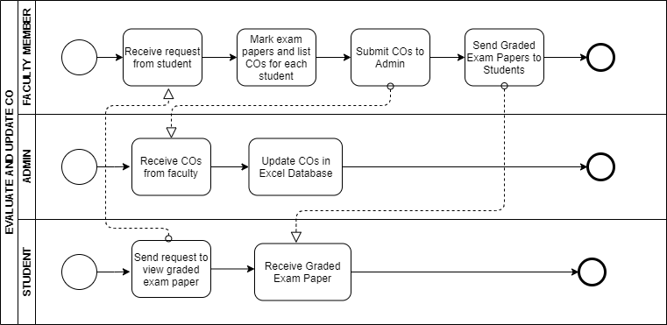

Figure 1.1: Evaluate and update CO

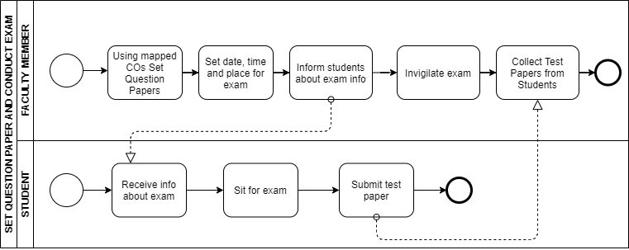

Figure 1.2: Set question paper and conclude exam

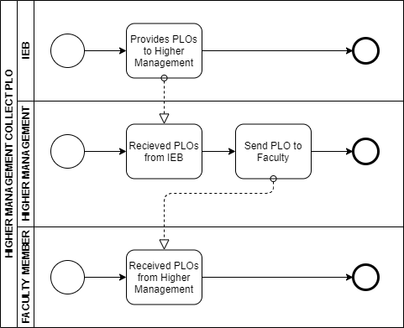

Figure 1.3: Higher management collect PLO

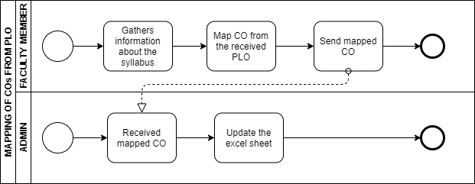

Figure 1.4: Mapping of CO from PLO

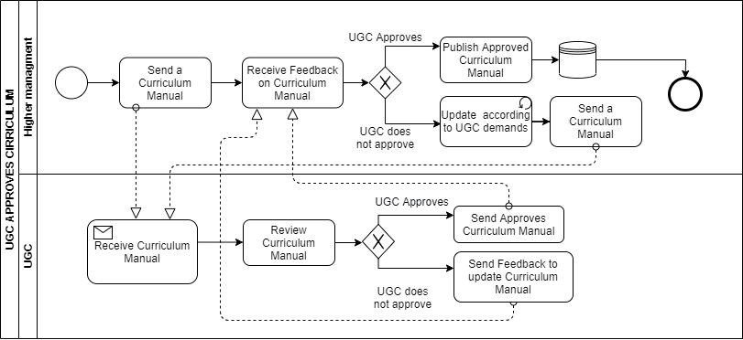

Figure 1.4: UGC approves curriculum

# 2.4 PROBLEM ANALYSIS – EXISTING BUSINESS SYSTEM:

Based on the existing systems’ Six Elements Analysis, the shortcomings in each process were identified. There is a repeating pattern in the far-right column of this table. It appears that the facilitation of a private online platform will improve the system in many ways.

|  |  |  |  |  |
| --- | --- | --- | --- | --- |
| **Process Name** | **Stakeholders** | **Concerns (Problems)** | **Analysis (Reason of the Problems)** | **Proposed Solution** |
| Student Enrollment | 1. Student  2. Department Head  3. Registrar’s office  4. Faculty  5. Dean  6. VC | School-wise, department-wise and program-wise comparison of students have enrolled in each  department with respect to a given period of time/semesters. | Student enrolled stats is recorded School, department and program-wise but was never compared with respect to time period/semester(s). | We want to keep the in the count of students enrolled along with a visual comparison of the student stats as per school-wise, department-wise and program-wise and semester-wise |
| Student performance  based on CGPA | 1. Student  2. Department Head  3. Registrar’s office  4. Faculty  5. Dean  6. VC | School-wise, department-wise and program-wise student performance trends  based on CGPA with respect to a given period of time/semesters. | Students and other mentioned stakeholders have been able to only observe the CGPA status that gets updated every semester individually | Our system should be allowing the users to statistically analyze the CGPA progress of the students not only on individually but also based on schools, department and program with respect to a given period of time/semesters |
| Course-wise student performance based on GPA | 1. Student  2. Department Head  3. Registrar’s office  4. Faculty  5. Dean  6. VC | Course-wise (for a selection of courses) student performance trend based on GPA with respect to a given period of time/semesters. | The GPA of the students were used as verdicts only and never visualize into course-wise student’s performance based of their GPA. | Through the software application the Stakeholders would be able to select the course and view performance trend depending on the GPA with respect to a given period of time/semesters. |
| Selective Number of Instructor-wise student performance based  on the GPA of the students | 1. Department Head  2. Registrar’s office  3. Faculty  4. Dean  5. VC | Instructor-wise (for a selection of instructors) student performance trend based  on the GPA of the students in that courses taught by each of the instructors so far  with respect to a given period of time/semesters. | Higher Authorities have been unable to observe the statistics of their selective faculties performances all together based on the GPA of the students | The SPM v2.0 system would allow to record the GPA of the students taught by the selective number of faculties. Storing and converting the data to appropriate graphical forums and measure performance of the instructors with respect to a given period of time/semesters.  with respect to a given period of time/semesters. |
| VC-wise, dean-wise, or department head-wise student performance | 1. Student  2. Department Head  3. Registrar’s office  4. Faculty  5. Dean  6. VC | VC-wise, dean-wise, or head-wise student performance trend based on the GPA of the students under the school/program corresponding to the leadership team. | Higher authority (VC/Dean and Department Head) was unable to view VC, Dean or Department Head-wise student’s performance under school/program | The system would  Will be able to visualize the performance of the students based on VC, Dean and Department-head |
| Instructor-wise student performance based  on the GPA of the students | 1. Department Head  2. Registrar’s office  3. Faculty  4. Dean  5. VC | Instructor-wise student performance trend for a chosen course with respect to a  given period of time/semesters. | Higher authorities was not able to monitor Instructor performance for a selected number of faculty based on the GPA of the students they have taught. | The SPM v2.0 system would allow the stakeholders to record the GPA of the students taught by the selective faculty. Storing and converting the data to appropriate graphical forms and measure performance of the instructors with respect to a  given period of time/semesters |
| Total PLO percentage achieved and attempted by the student along with the departmental average | 1. Student  2. Department Head  3. Registrar’s office  4. Faculty  5. Dean  6. VC | PLO total percentage score for each PLO calculated from the scores achieved in  each CO associated with the corresponding PLO among all the courses the  student has done so far, along with the departmental average performance for comparison. Also, for each PLO, what percentage of it was achieved from each of  the courses associated with the corresponding PLO, and what percentage was achieved via each of all the COs associated with the corresponding PLO. All of this for a chosen school, program, or department. | The PLO and corresponding CO for all the courses the student has done so far is never compared cumulatively along the departmental average performance. | The system will provide the total of all PLO percentage corresponding to CO and calculate the score for all the courses a student has done for a chosen school, program or department. |
| PLO achievement | 1. Student  2. Department Head  3. Registrar’s office  4. Faculty  5. Dean  6. VC | PLO achievement of a student for each of the courses taken so far. | Students are unable to monitor progress of their PLO achieved for respective courses as it only available to the faculties and has access to rest of the higher authorities. | Record and tabulate the number of PLO’s achieved by the student for individual course taken and completed so far. |
| Comparison of PLO-achieved percentage versus PLO-attempted | 1. Student  2. Department Head  3. Registrar’s office  4. Faculty  5. Dean  6. VC | Comparison of PLO-achieved percentage versus PLO-attempted percentage | Students are unable to compare progress of their PLO achieved vs PLO they should be aiming for with respect to courses they’ve done as it only available to the faculties and is analysed manually and canbe extremely time consuming | The system would allow the students and rest of the stakeholders to monitor automatically using relational data model using proper SQL operations- their PLO achieved vs attempted comparisons individually. |
| Expected PLO-achievement versus actual score (For course’s, student’s, department’s, program’s, or school’s) | 1. Student  2. Department Head  3. Registrar’s office  4. Faculty  5. Dean  6. VC | Comparison of a course’s, student’s, department’s, program’s, or school’s expected PLO-achievement versus actual with respect to a given period of time/semesters. | The existing system allows to calculate manually and does not provides adequate information for comparisons of PLO. The verdict is filled up in an Excel sheet and is time consuming for the stakeholders to reach to respective faculties or department head for OBE mark sheet. | SPM software would allow the stakeholders to monitor automatically (login into the system) their PLO achieved vs attempted comparisons for course’s, program’s, department’s and school with respect to a given period of time/semesters. |
| CO-PLO achievement summary | 1. Student  2. Department Head  3. Registrar’s office  4. Faculty  5. Dean  6. VC | Summary of CO-PLO achievement stats for a chosen course, program, department, school. | The existing system by far was abled the higher authorities only to track CO and PLO achieved for a course manually only. | SPM in a table will provide PLO-CO achievement stats to the stakeholders to choose for course wise, program, department and school wise. |

# 2.5 RICH PICTURE - PROPOSED SYSTEM:

The Course Outcomes (COs) and Program Learning Outcomes (PLOs) will be visible in a new system, an online platform called SPMS, where it will have its own database that host the data of all the courses, faculties, as well as updated tables every semester to keep track of which courses have been assigned to which faculties in a given semester. We are making the new system (to track student performance, but also to track faculties teaching a specific course or the performance of students in a course over a period) and why it is hard to track these trends and data right now. Briefly, we can see that the SPMS relational database (a non-human) quite literally plays a significant role in the student performance monitoring system. Also, this entity holds the greatest number of interconnections between all other processes.

We will use different user interfaces designed for specific user needs based on the concerns and problems we found in the problem analysis. The Head of the Department/Dean of School, Course Instructor/Coordinator/Faculty, Admin, Student, IEB/UGC/Ministry of Education, VC/Board of Trustees, Department Staff, all these stakeholders mentioned will have access to view the report of a student.

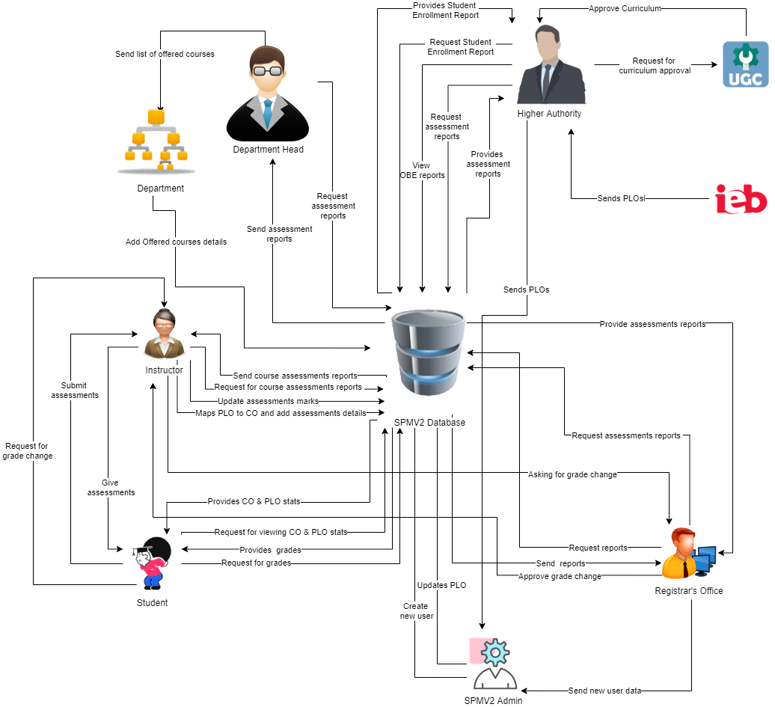

Figure 1.5: Rich Picture of Proposed System to Monitor Student Performance.

# 2.6 SIX ELEMENTS ANALYSIS – PROPOSED SYSTEM:

The six elements analysis of the proposed system is a continuation of an analysis process where each analysis is based on the one that comes before it. Based on the rich picture, the role of each element in the new system is further understood in the table below.

|  |  |  |  |  |  |  |
| --- | --- | --- | --- | --- | --- | --- |
| Process | System Roles | | | | | |
| Human | Non-Computing Hardware | Computing Hardware | Software | Database | Network and Communication |
| **Student Enrollment** | **Student**  a) Goes to the website b) Clicks on the form option  c) Fills the form with required information  **Registrar Office**  a) Checks and verifies student enrollment information from the forms from the website or hardcopy forms  b) Registrar Office’s Admin logs into the system using adminID and password.  c)Sends verified student information as an attachment to SPMV2 Admin/Team  **SPMV2 Admin**  a) SMPV2.0 Admin logs into the system using SPMV2userID and password.  b) Receives the student enrollment information in the attached files.  c)Admin updates the student enrollment information in SPMV2 Database.  d)Notifies respected Stakeholders.  **Department Head**  a) Logs into the system using their UserID and password.  b) Inputs the desired time-period for number of students enrolled.  **Higher Authority (VC/Dean)**  a) Logs into the system using their UserID and password.  b) Inputs the desired time-period and compare School/Department for the number of students enrolled accordingly.  **Faculty**  a)logs into the system using FacultyID and password b)Inputs the ID of the section the faculty is taking to view the students enrolled. | **Paper and**  **Stationary**  a) Used to  collect  information in  forms from  Students | **Computer/**  **Laptop**  a) SPMV 2.0 admin will use  Computers to access and update data.   b) Users will use the  computer to view the data.  **Database**  **Server**  a) Used by  SPMV 2.0  Developers to collect data and maintain the software.  **Networking Devices**  **(Router,**  **Switch,**  **Bridge, Hub):**  a) Used to  access SPMV 2.0. | **Operating**  **Software**  Used by  Registrar Office and SPMV 2.0  **Student**   Uses to fill the form when filling the form from the website  **SPMV2.0**  The software for which the admin will  create  accounts | **Register Office Database**  Used By the registrar office to collect the student information in a excel file to send it to SPMV 2.0  **SPMV2.0**  Information is stored in the Database for New user Account or any other updates  **Excel**  Student account data may be stored in excel file for later usage in SPMV2.0. | **Internet**  a) Its is used to access and store data to SPMV2.0  b) Used to collect the student form from the student to registrar office  c) Used by the Registrar Office to send all the student information to SPMV 2 Admin |
| **Student Performance Based on CGPA** | **Student**  a) Logs into the System using StudentID and password.  b) Inputs the desired time-period to view self CGPA progress  **Department Head**  a)Logs into the System using UserID and password.  b) Inputs the desired time-period and School, Department or Program  c)View statistically analyzed CGPA trend of students or any Individual Student  **Registrar’s office**  a) Logs into the System using userID and password.  b) Inputs the desired time-period and School, Department or Program to view statistically analyzed CGPA trend of students.  **Faculty**  a) Logs into the System using FacultyID and password.  b) Inputs the desired time-period and Program to view statistically analyzed CGPA trend of students or any Individual Student those who attended the faculty’s section.  **Higher Authority (Dean/VC)** a) Logs into the system using their UserID and password.  b) Inputs the desired time-period, School and Department  c) View statistically analyzed CGPA trend of students | N/A | **Computer/**  **Laptop**  a) User will need a computer to access SPMV 2.0  **Printer**  a) Used to print out the report if need be  **Networking Devices**  **(Router,**  **Switch,**  **Bridge, Hub):**  a) Used to  access the  Internet. | **Operating**  **Software**  Used by the user to run SPMV2.0  **SPMV2.0**  a) The software will generate a performance trend | **SPMV2.0 Database**  a) Use the database to obtain the performance.  b) Used for saving the obtained performance of each student | **Internet**  a)It is used to login into and access the SPMV2.0  b)Used by the users to login and get access of the system |
| **Course-wise student performance based on GPA** | **Student**  a) Logs into the System using StudentID and password.  b) Inputs the course  c) View self GPA for the course  **Department Head**  a) Logs into the System using UserID and password.  b) Inputs the desired time-period courseID  c)View statistically analyzed GPA trend of students    **Registrar’s office**  a) Logs into the System using adminID and password.  b) Inputs the desired time-period and coursed  c) view statistically analyzed GPA trend of students.  **Faculty**  a) Logs into the System using FacultyID and password.  b) Inputs the desired time-period CourseID under the faculty  c)view statistically analyzed GPA trend of students who were in that faculty’s section.    **Higher Authority (Dean/VC)** a) Logs into the system using their UserID and password.  b) Inputs the desired time-period and CourseID  c) View statistically analyzed GPA trend of students for that specific course | N/A | **Computer/**  **Laptop**  a) User will need a computer to access SPMV 2.0  **Printer**  a) Used to print out the report if need be  **Networking Devices**  **(Router,**  **Switch,**  **Bridge, Hub):**  a) Used to  access the  Internet. | **SPMV2.0**  a) The software will generate a performance trend based of GPA  **Operating**  **Software**  Used by the user to run SPMV2.0 | **SPMV2.0 Database**  a) The performance will be stored and updated here | **Internet**  a) It is used by the user to log in  b)It is used by the user to view desired data |
| **Selective Number of Instructor-wise student performance based**  **on the GPA** | **Department Head**  a) Logs into the System using UserID and password.  b) Inputs the desired time-period courseID c)View statistically analyzed GPA trend of students for a selective number of Instructors  **Registrar’s office**  a) Logs into the System using AdminID and password.  b) Inputs the desired time-period and courseID  c)View statistically analyzed GPA trend of students for a selective number of Instructors  **Faculty**  a) Logs into the System using FacultyID and password.  b) Inputs the desired time-period & courseID  c)View statistically analyzed GPA trend of students for a selective number of Instructors  **Higher Authority (Dean/VC)**  a) Logs into the System using UserID and password.  b) Inputs the desired time-period courseID  c)View statistically analyzed GPA trend of students for a selective number of Instructors. | N/A | **Computer/**  **Laptop**  a) User will need a computer to access SPMV 2.0  **Printer**  a) Used to print out the report if need be  **Networking Devices**  **(Router,**  **Switch,**  **Bridge, Hub):**  a) Used to  access the  Internet. | **SPMV2.0**  a) The software will generate a performance trend for a selective instructor wise | **SPMV2.0 Database**  a) The performance will be stored and updated here | **Internet**  a) It is used to login into and access the SPMV2.0 |
| **VC-wise, dean-wise, or department head-wise student performa**  **nce** | **Department Head**  a) Logs into the System using UserID and password.  b) Select Input from from VC/Dean/Department Head  c)View the student performance trend as per choice.  **Registrar’s office**  a) Logs into the System using UserID and password.  b) Select Input from VC/Dean/Department Head  c)View the student performance trend as per choice  **Dean/ VC**  a) Logs into the System using UserID and password.  b)Select Input from VC/Dean/Department Head  c)View the student performance trend as per choice | N/A | **Computer/**  **Laptop**  a) User will need a computer to access SPMV 2.0  **Printer**  a) Used to print out the report if need be  **Networking Devices**  **(Router,**  **Switch,**  **Bridge, Hub):**  a) Used to  access the  Internet. | **SPMV2.0**  a) The software will generate a performance trend | **SPMV2.0 Database**  a) The performance will be stored here | **Internet**  a) It is used to login into and access the SPMV2.0 |
| **Instructor-wise student performance based**  **on the GPA of the students** | **Department Head**  a) Logs into the System using DepartmentID and password.  b) Inputs a particular instructor Name/ID  c)View the student performance trend of selected instructor.  **Registrar’s office**  a) Logs into the System using UserID and password.  b) Inputs a particular instructor  c)View the student performance trend of selected instructor  **Faculty**  a) Logs into the System using UserID and password.  b) Input their Name/ID  c)View the student performance trend  **Dean**  a) Logs into the System using UserID and password.  b)Inputs a particular instructor  c)View the student performance trend of selected instructor.  **VC**  a) Logs into the System using UserID and password.  b) Inputs a particular instructor  c)View the student performance trend of selected instructor | N/A | **Computer/**  **Laptop**  a) User will need a computer to access SPMV 2.0  **Printer**  a) Used to print out the report if need be  **Networking Devices**  **(Router,**  **Switch,**  **Bridge, Hub):**  a) Used to  access the  Internet. | **Operating**  **Software**  Used by  User to view desired performance trend | **SPMV2.0 Database**  a) The performance will be stored and updated in the database | **Internet**  a) It is used to login into and access the SPMV2.0 |
| **Total PLO percentage achieved and attempted by the student along with the departmental average** | **Student**  a) Logs into the system using Student ID and Password  b) Inputs the time period  c)Views their comparison of attempted vs achieved PLO percentage along with the departmental average.  **Department Head**  a) Logs into the system using User ID and Password  b) Inputs the time period  c)Views the comparison of students attempted PLO vs achieved PLO percentage along with the departmental average.  **Registrar’s office**  a) Logs into the system using User ID and Password  b) Inputs the time period  c)Views the comparison of students attempted PLO vs achieved PLO percentage along with the departmental average.  **Faculty**  a) Logs into the system using User ID and Password  b) Inputs the time period  c)Views the comparison of students attempted PLO vs achieved PLO percentage along with the departmental average.  **Dean**  a) Logs into the system using User ID and Password  b) Inputs the time period  c)Views the comparison of students attempted PLO vs achieved PLO percentage along with the departmental average.  **VC**  a) Logs into the system using User ID and Password  b) Inputs the time period  c)Views the comparison of students attempted PLO vs achieved PLO percentage along with the departmental average. | N/A | **Computer/**  **Laptop**  a) User will need a computer to access SPMV 2.0  **Printer**  a) Used to print out the report if need be  **Networking Devices**  **(Router,**  **Switch,**  **Bridge, Hub):**  a) Used to  access the  Internet. | **SPMV2.0**  a) The software will generate a comparison of attempted vs achieved PLO as well as the departmental average  **Operating system**  a) Used by the SPMV2.0 to keep details of the PLO and CO of each students  **Student**   Uses Database to view self PLO achieved | **SPMV2.0 Database**  a) The performance will be stored here | **Internet**  a) It is used to login into and access the SPMV2.0 |
| **PLO achievement** | **Student**  a) Logs into the System using studentID and password.  b) Selects PLO achievement  c) view PLO achievement.  **Department Head**  a) Logs into the System using userID and password.  b) Selects PLO achievement  c) view PLO achievement.  **Registrar’s office**  a) Logs into the System using userID and password.  b) Selects PLO achievement  c) view PLO achievement.  **Faculty**  a) Logs into the System using facultyID and password.  b) Selects PLO achievement  c) view PLO achievement.  **Dean**  a) Logs into the System using userID and password.  b) Selects PLO achievement  c) view PLO achievement.  **VC**  a)Logs into the System using userID and password.  b) Selects PLO achievement  c) view PLO achievement. | N/A | **Computer/**  **Laptop**  a) User will need a computer to access SPMV 2.0  **Printer**  a) Used to print out the report if need be  **Networking Devices**  **(Router,**  **Switch,**  **Bridge, Hub):**  a) Used to  access the  Internet. | **SPMV2.0**  a) The software will generate PLO achievement | **SPMV2.0 Database**   1. The performance will be stored and updated here | **Internet**  a)It is used to login into and access the SPMV2.0 |
| **Comparison of PLO-achieved percentage versus PLO-attempted** | **1. Student** a) Logs into the System using studentID and password.  b) Selects PLO Achieved Vs Attempts  c) Uses SQL operation  d) Monitor self-relational data model of the PLO achieved and attempted  **2. Department Head** a) Logs into the System using UserID and password.  b) Selects PLO Achieved Vs Attempts  c) Uses SQL operation  d) Monitor relational data model of the PLO achieved and attempted by individual student or the comparison as desired  **3. Registrar’s office** a) Logs into the System using userID and password. b) Selects PLO Achieved Vs Attempts  c) Uses SQL operation  d) Monitor relational data model of the PLO comparison as desired  **4. Faculty**  a) Logs into the System using FacultyID and password. b) Selects PLO Achieved Vs Attempts  c) Uses SQL operation  d) Monitor relational data model of the PLO achieved and attempted by individual student or the comparison as desired in that faculty’s class  **5. Dean** a) Logs into the System using userID and password. b) Selects PLO Achieved Vs Attempts  c) Uses SQL operation  d) Monitor relational data model of the PLO achieved and attempted by individual student or the comparison as desired in the school  **6. VC** a) Logs into the System using userID and password. b) Selects PLO Achieved Vs Attempts  c) Uses SQL operation  d) Monitor relational data model of the PLO achieved and attempted by individual student or the comparison as desired | N/A | **Computer/**  **Laptop**  a) User will need a computer to access SPMV 2.0  **Printer**  a) Used to print out the report if need be  **Networking Devices**  **(Router,**  **Switch,**  **Bridge, Hub):**  a) Used to  access the  Internet. | **Operating**  **Software**  Used by  User to access dashboard  **Student**   Uses to view the report | **Database** a) Used by Higher Authority to access SPMV2.0 Data base to view report  b) Used by faculty and Department Head to view report of each student  and if comparison as desired  c) Used by student to monitor self PLO achieved percentage versus PLO attempted | **Internet**  a) Its is used to access and store data to SPMV2.0  b) Used by the stake Holders to login to the SPMV2.0 Dashboard  c) Used by the stakeholders to monitor PLO achieved percentage versus PLO attempted as per their requirement |
| **Expected PLO-achievement versus actual score (For course’s, student’s, department’s, program’s, or school’s**  **)** | **Student**  a) Logs into the System using studentID and password.  b) Selects PLO achievement comparison  c) Enters period of time/semesters d) monitor self PLO achieved vs attempted comparisons for course’s  **Department Head**  a) Logs into the System using userID and password.  b) Selects PLO achievement comparison  c) Enters period of time/semesters d) monitor PLO achieved vs attempted comparisons for course’s, programs and department’s individual student or as per desired  **Registrar’s office**  a) Logs into the System using userID and password.  b) Selects PLO achievement comparison c) Enters period of time/semesters  d) monitor PLO achieved vs attempted comparisons for course’s, program’s, departments and school  **Faculty**  a) Logs into the System using FacultyID and password.  b) Selects PLO achievement comparison c) Enters period of time/semesters d) monitor PLO achieved vs attempted comparisons for courses of the students who attended that faculty’s section  **Dean**  a)Logs into the System using userID and password.  b) Selects PLO achievement comparison c) Enters period of time/semesters  d) monitor PLO achieved vs attempted comparisons for course’s, program’s, departments and school  **VC**  a) Logs into the System using userID and password.  b) Selects PLO achievement comparison c) Enters period of time/semesters  d)monitor PLO achieved vs attempted comparisons for course’s, program’s, department’s and school with respect to a given period of time/semesters . | N/A | **Computer/**  **Laptop**  a) User will need a computer to access SPMV 2.0  **Printer**  a) Used to print out the report if need be  **Networking Devices**  **(Router,**  **Switch,**  **Bridge, Hub):**  a) Used to  access the  Internet. | **Operating**  **Software**  Used by  User to access dashboard  **Student**   Uses to view self-comparison report   **Faculty and Department Head** Uses to monitor the comparison between the student’s attempted PLO and achieved PLO for Course wise and Department wise  **Higher Authority**  Uses to monitor the comparison between the student’s attempted PLO and achieved PLO for course’s, program’s, departments and school | **SPMV2.0 Database**  a) The performance will be stored and updated in the database | **Internet**  a) It is used to login into and access the SPMV2.0 |
| **CO-PLO achievement summary** | **Student**  a)Logs into the System using studentID and password.  b) Selects  CO-PLO Table  c) view CO-PLO achievement summary  **Department Head**  a) Logs into the System using userID and password.  b) Selects  CO-PLO achievement summary  c) view CO-PLO achievement summary  **Registrar’s office**  a) Logs into the System using userID and password.  b) Selects  CO-PLO achievement summary  c) view CO-PLO achievement summary  **Faculty**  a) Logs into the System using facultyID and password.  b) Selects  CO-PLO achievement summary  c) view CO-PLO achievement summary  **Dean**  a) Logs into the System using userID and password.  b) Selects  CO-PLO achievement summary  c) view CO-PLO achievement summary  **VC**  a) Logs into the System using userID and password.  b) Selects  CO-PLO achievement summary  c) view CO-PLO achievement summary | N/A | **Computer/**  **Laptop**  a) User will need a computer to access SPMV 2.0  **Printer**  a) Used to print out the report if need be  **Networking Devices**  **(Router,**  **Switch,**  **Bridge, Hub):**  a) Used to  access the  Internet. | **SPMV2.0**  a) The software will generate the summary of CO-PLO achievement | **SPMV2.0 Database**  a) The Summary will be stored and updated in the database | **Internet**  a) It is used to login into and access the SPMV2.0 |

# 2.7 PROCESS MODEL - PROPOSED SYSTEM:

After understanding the role of each element in each process, the Business process model and notation provides an unambiguous dictation of the exact sequence of steps that will follow to fulfill each process. Every module of this diagram will serve as a high-level starting point for deriving the implementation details in the later chapter.

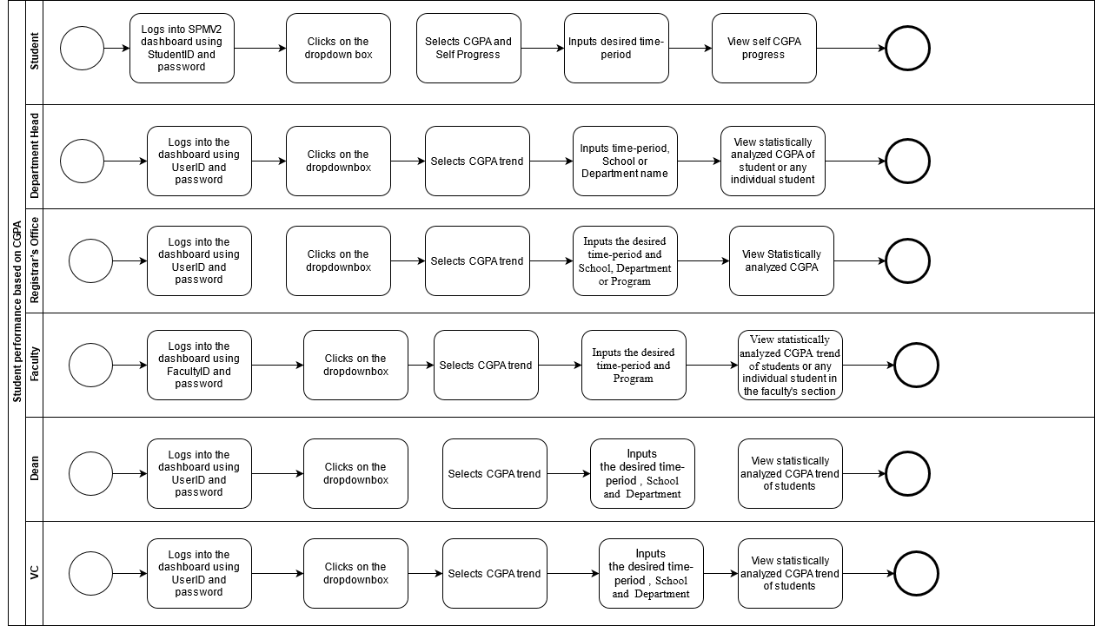

**Fig: Student Performance based on CGPA(Process)**

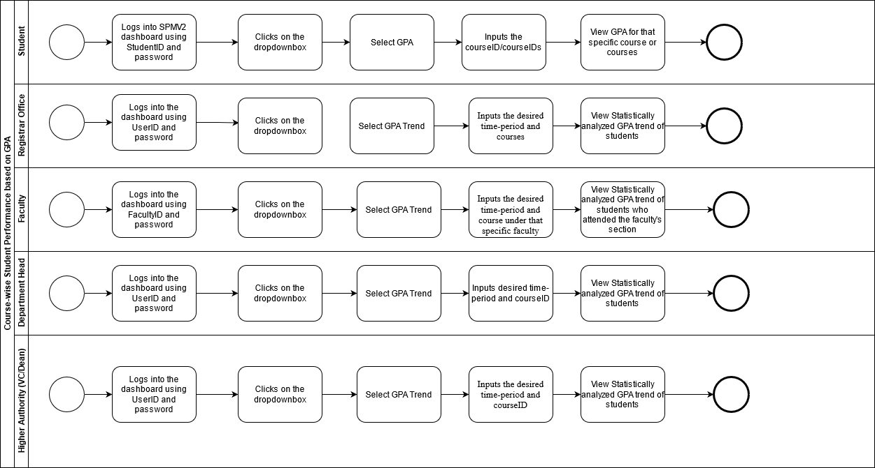

**Fig: Course-wise Student Performance based on GPA(Process)**

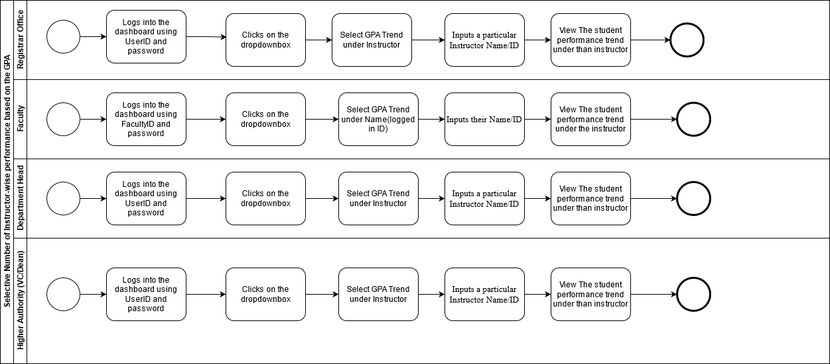

**Fig: Selective Number of Instructor-wise performance based on the GPA(Process)**

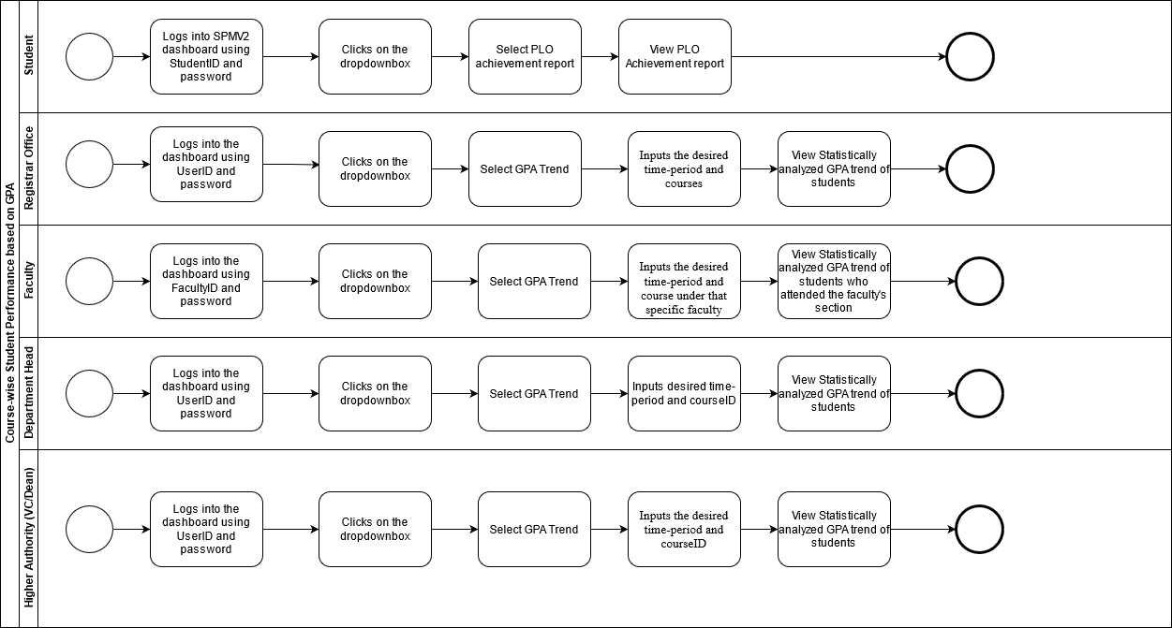

**Fig: Course-wise Student Performance based on GPA(Process)**

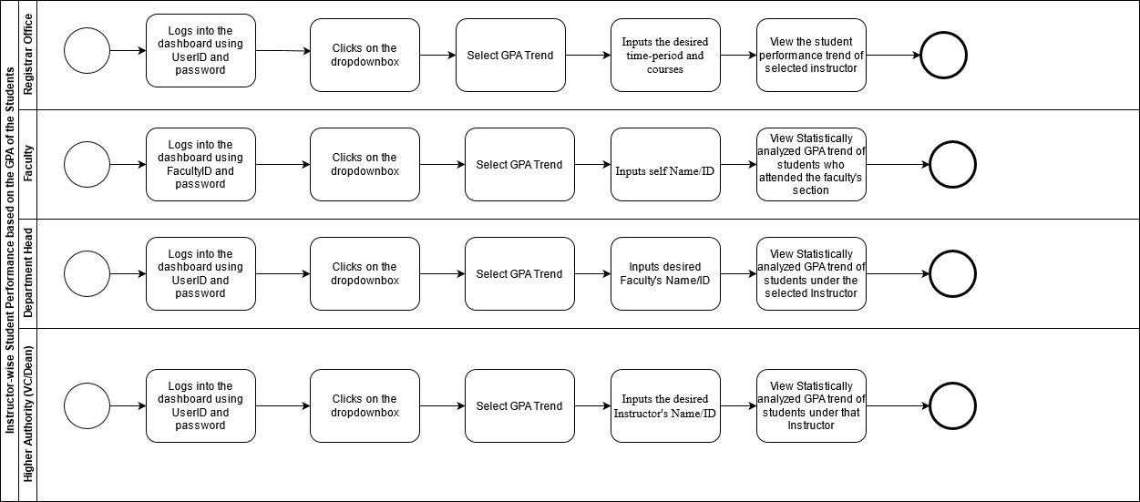

**Fig: Instructor-wise Student Performance based on the GPA of the Students**

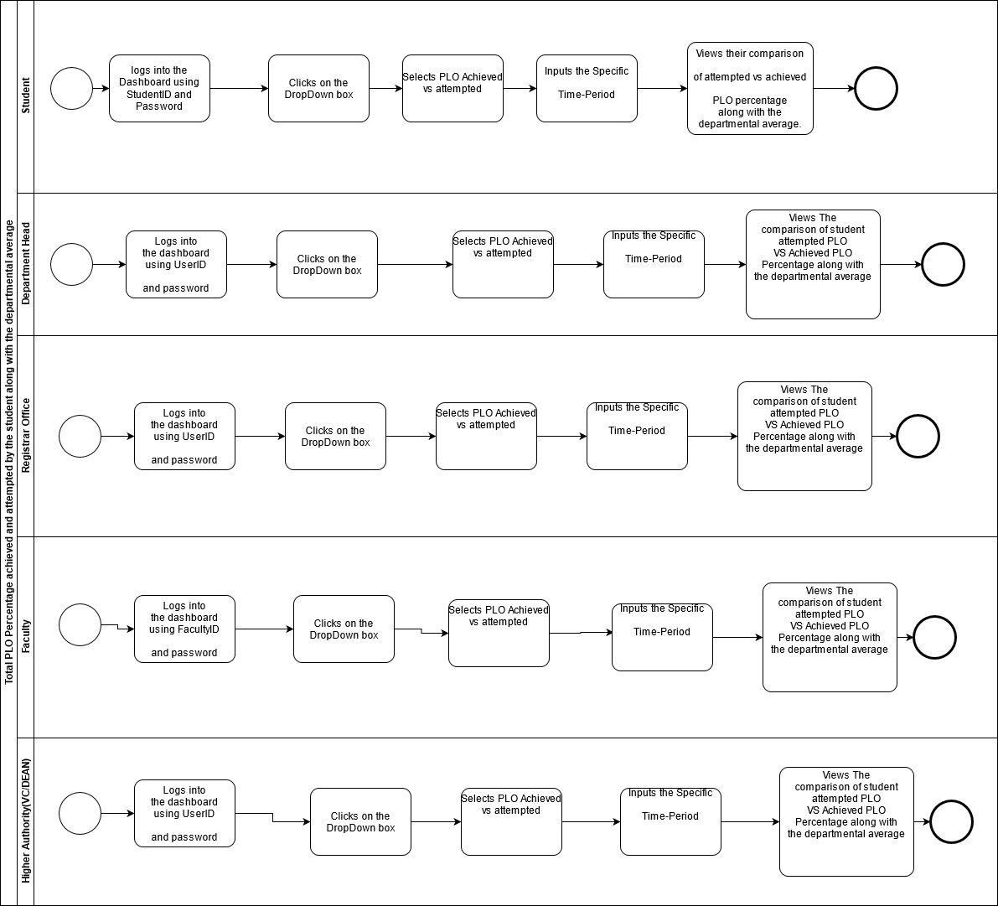

**Fig: Total PLO Percentage achieved and attempted by the student along with the departmental average**

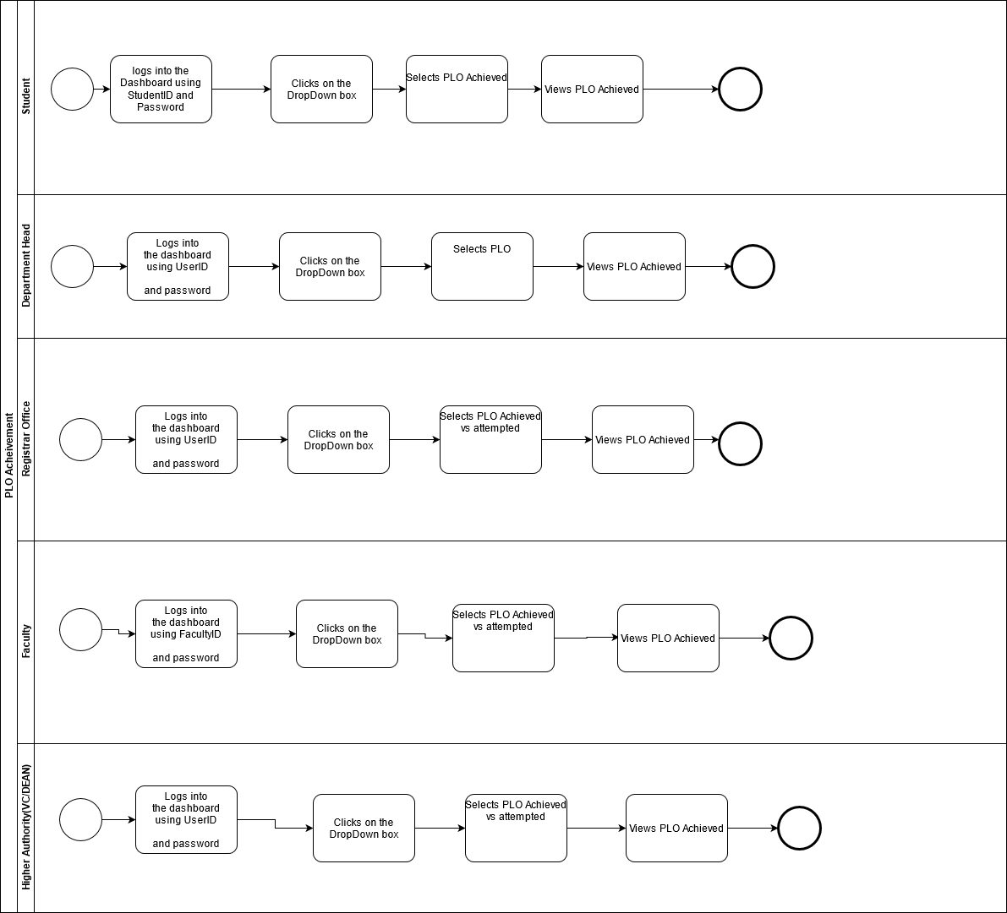

**Fig. PLO Achievement (Process)**

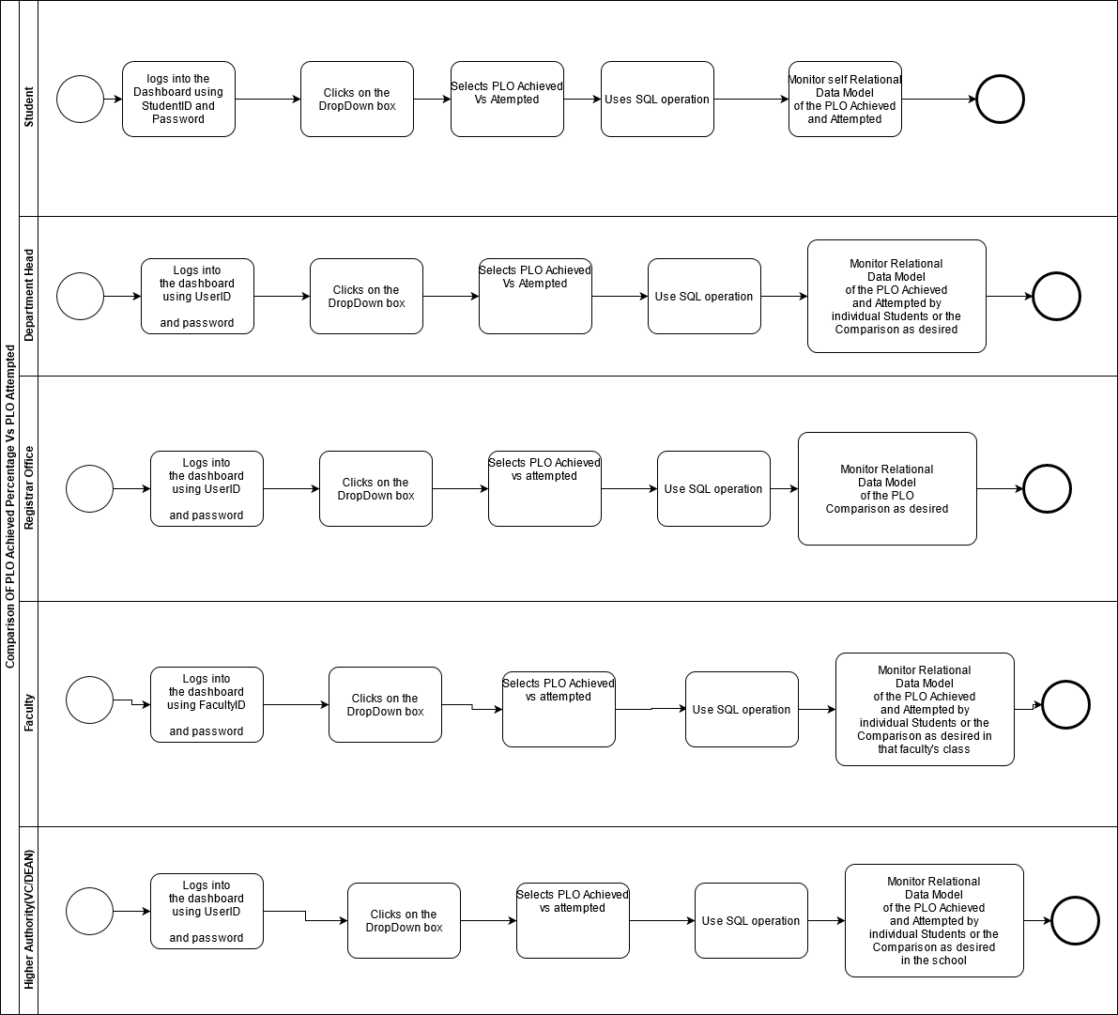

**Fig: Comparison of PLO Achieved vs Attempted (Process)**

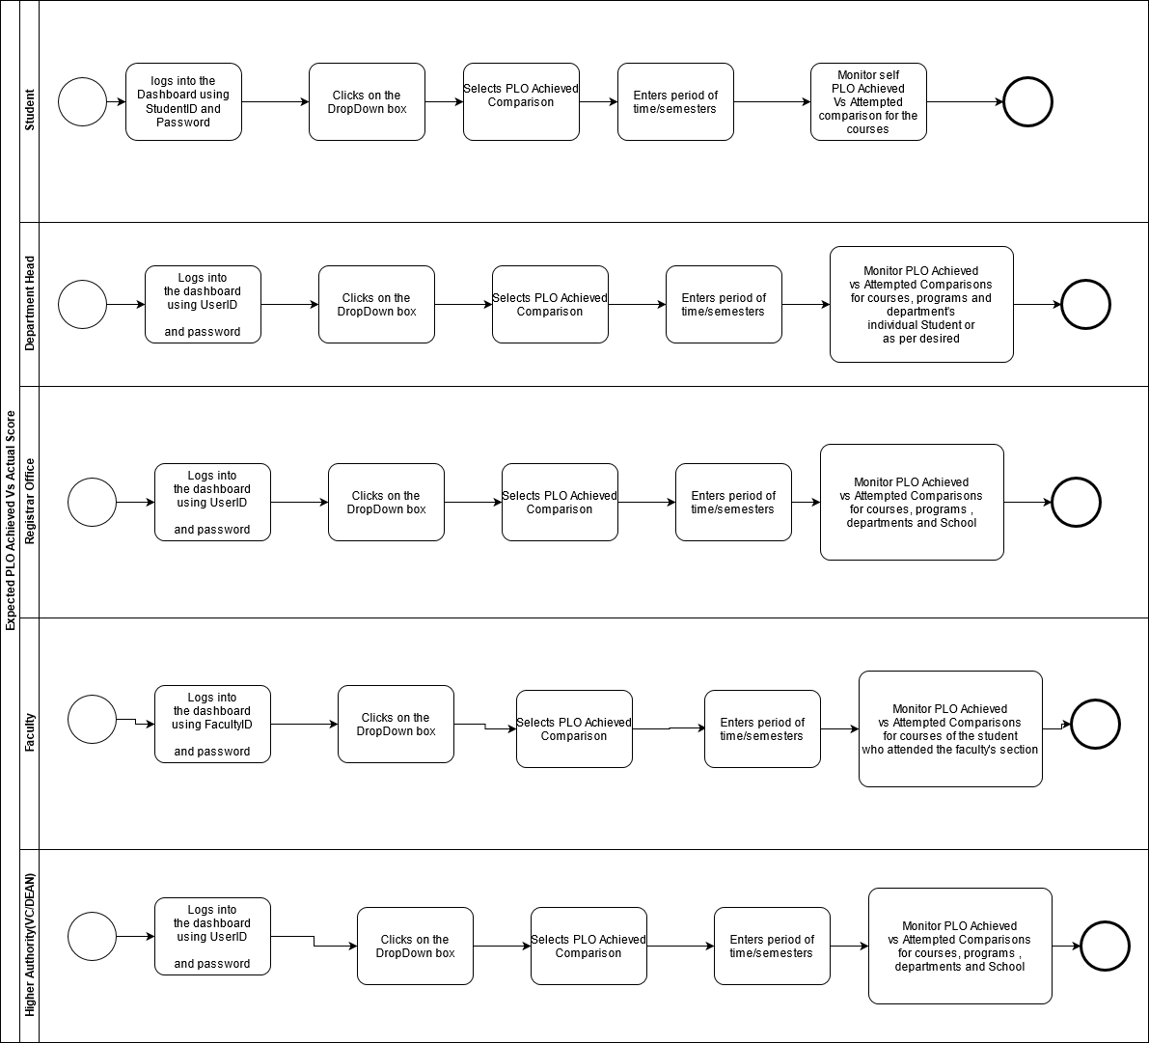 Fig. **FIG: Expected PLO Achieved Vs Actual Score (Process)**

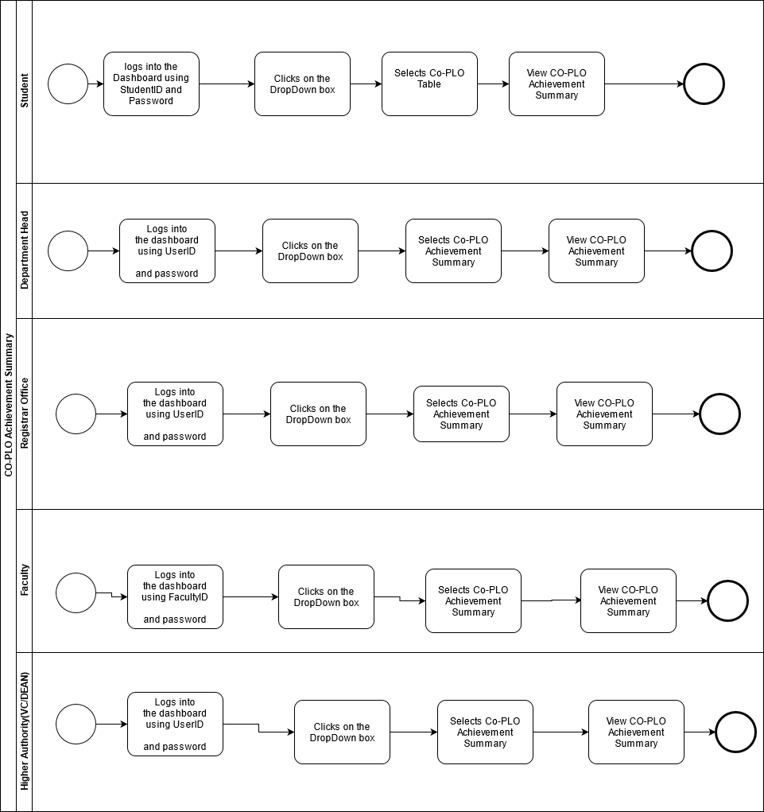

**Fig. CO-PLO Summary (Process)**

# **Chapter-3.0 LOGICAL SYSTEM DESIGN:**

In this chapter, we will be doingthe processes of creating a data model of our proposed system for the data to be stored in a database. This data model is a conceptual representation of Data objects, the associations between different data objects, and the rules. Data modeling helps in the visual representation of data and enforces business rules, regulatory compliances, and government policies on the data. Data Models ensure consistency in naming conventions, default values, semantics, security while ensuring quality of the data. We will be designing our proposed system for a better representation of all the data.

# 3.1 BUSINESS RULE [ SPMS V2.0 ]:

Business rules describe the operations, definitions and constraints that govern the data model. As opposed to the ERD, they are made using regular English sentences so that a non-technical stakeholder can decipher information about the data model without notation knowledge.  
The business rules that govern our data model are as follows:

1. A student must have one department. A STUDENT has StudentID, FirstName, LastName, DateofBirth, Gender, Email, Phone, Address, EnrollmentDate. A department must have many students.

2. Student may perform many registrations. A REGISTRATION includes RegistrationID, Semester, Year, Section Id, StutendID. A registration must be performed by at least one student.

3. A section mandatorily have many registrations. A registration has at least one section. A section includes SectionID, SectionNum, CourseId, FacultyID, Semester, Year.

4. A registration may belong to many EVALUATIONS. An evaluation mandatorily belongs to one registration. An evaluation contains EvaluationID, ObtainedMarks, AssessmentID, RegistrationID.

5. An evaluation must have one assessment. An Assessment must have many evaluations. Assessments contains AssesmentsID, AssessmentName, TotalMarks, SectionID, COID, QuestionNum, Weight. An assessment must contain one section. A section contains one or many assessments.

6. An assessment must map with one CO’s. A CO’s maps with one or many assessments. A CO’s includes COID, CourseID, PLOID. A CO must contain one Course. A Course contain one or many CO’s. A course may have many prerequisites.

7. A CO’s must map with one PLO’s. A PLO’s must map with one or many CO’s. PLO includes PLOID, PLONum, Details, ProgramID.

8. A PLO must contain one program. A program contains one or many PLO’s. A program has ProgramID, ProgramName, DepartmentID. A program must contain one or many courses. A Course must contain one course.

9. A program must belong to one department. A department must belong to one or many programs. A department contain DepartmentID, DepartmentName, SchoolID.

10. A department must contain one school. A School must contain one or many departments. A school includes SchoolID, SchoolName.

11. An employee has four sub-type( Dean, Department Head, Faculty, VC). An employee includes EmployeeID, FirstName, LastName, DateofBirth, Gender, Email, Phone, Address, EmployeeType.

12. A school must run by one or many Dean. A dean must run one school. A Dean has SchoolID, StartDate, EndDate.

13. A Department must manage one or many Department head. A department head must manage one department. A department head includes DepartmentID, StartDate, EndDate.

14. A Faculty must have one Department. A department must have one or many Faculties. A Faculty includes DepartmentID, Rank, JoinDate. A faculty may teach many sections. A section must be taught by one faculty.

# 3.2 ENTITY RELATIONSHIP DIAGRAM:

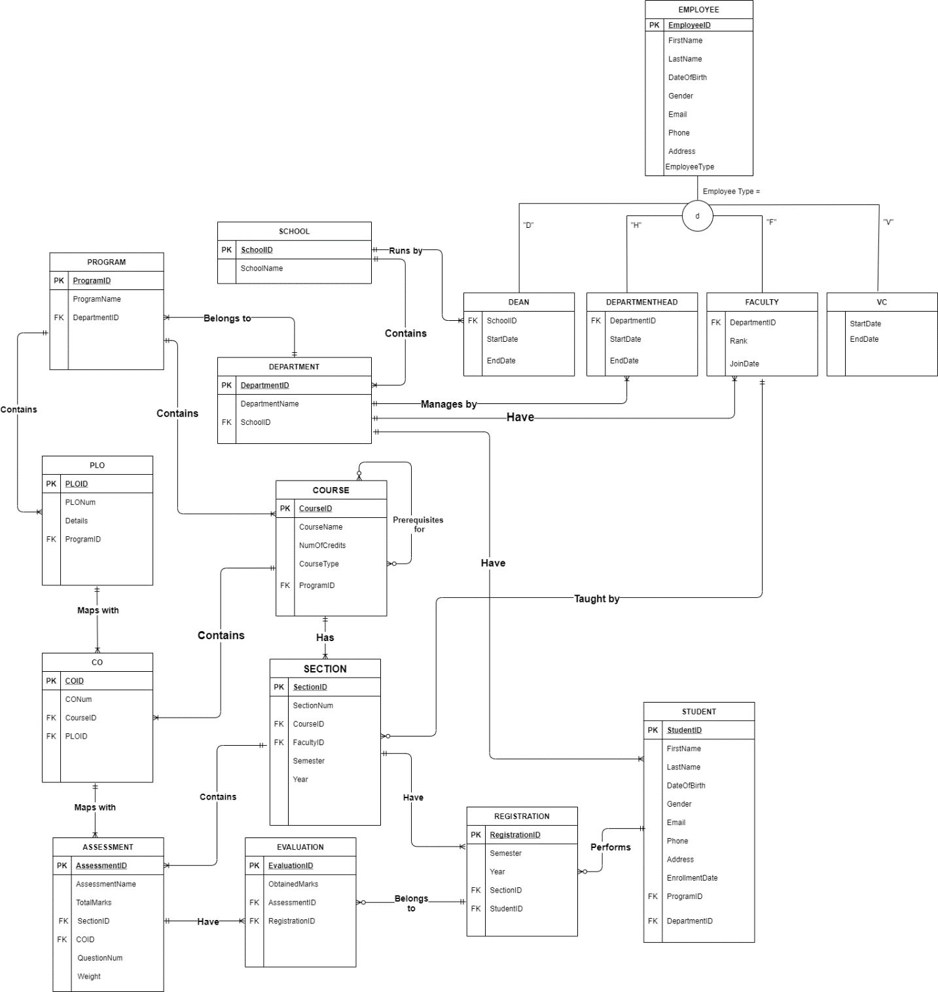

Figure: Entity relationship diagram

# 3.3 ENTITY RELATIONSHIP DIAGRAM TO RELATIONAL SCHEMA:

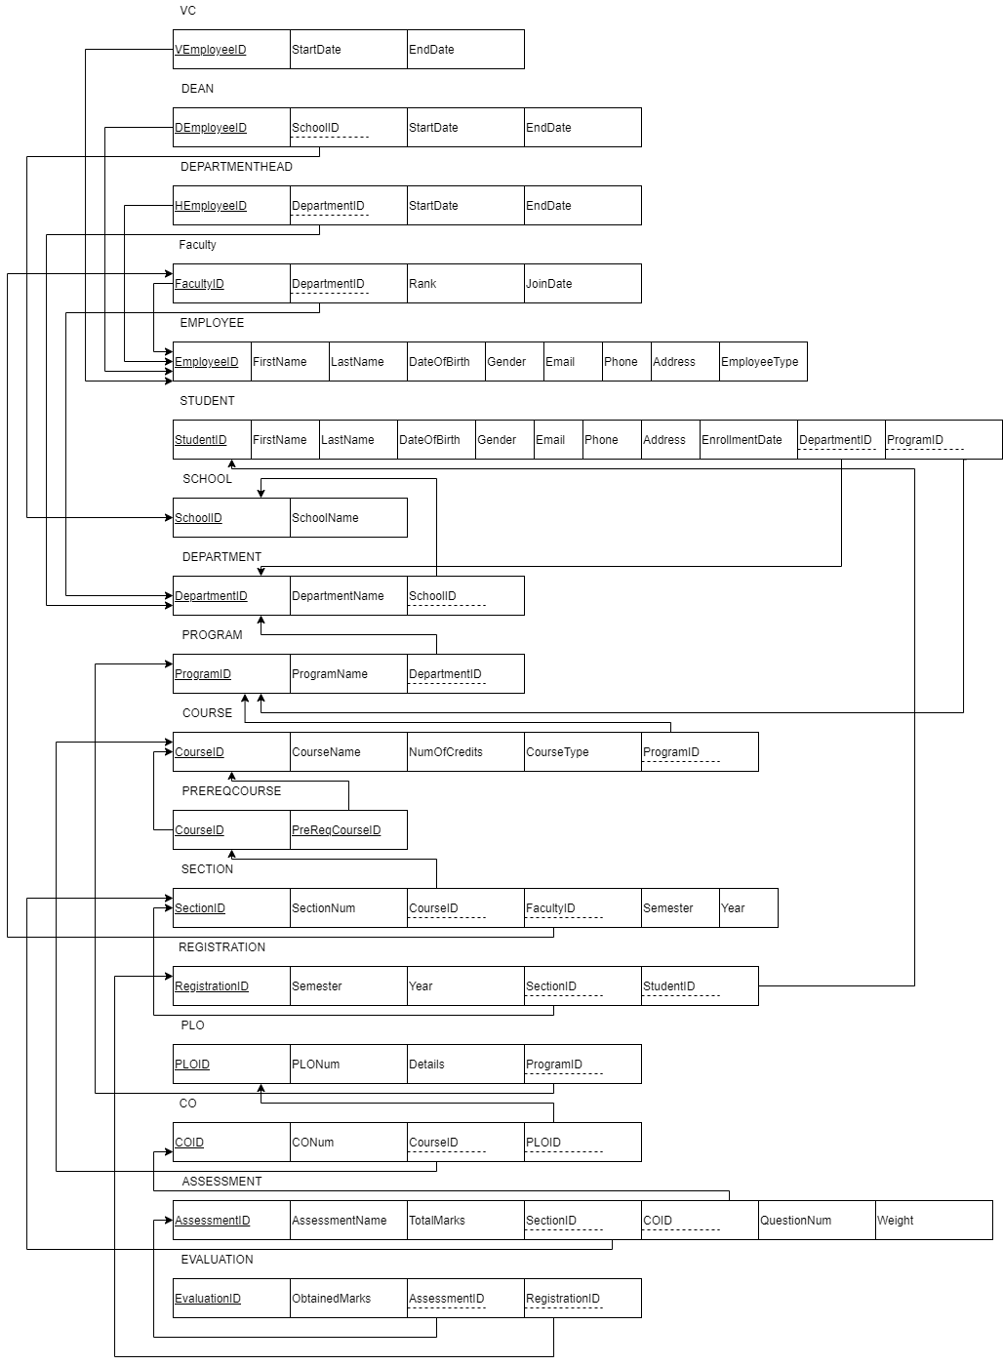

# 3.4 NORMALIZATION:

|  |  |  |  |  |  |
| --- | --- | --- | --- | --- | --- |
| Registration | RegistrationID | r1 | Evaluation | EvaluationID | e1 |
| Semester | r2 | ObtainedMarks | e2 |
| Year | r3 | AssessmentID | a1 |
| StudentID | s1 | RegistrationID | r1 |
| SectionID | q1 | Student | StudentID | s1 |
| Section | SectionID | q1 | FirstName | s2 |
| SectionNum | q2 | LastName | s3 |
| Semester | q3 | DateOfBirth | s4 |
| Year | q4 | Gender | s5 |
| CourseID | o1 | Email | s6 |
| FacultyID | f1 | Phone | s7 |
| Course | CourseID | o1 | Address | s8 |
| CourseName | o2 | EnrollmentDate | s9 |
| NumOfCredits | o3 | ProgramID | g1 |
| CourseType | o4 | DepartmentID | d1 |
| ProgramID | g1 | Employee | EmployeeID | m1 |
| Program | ProgramID | g1 | FirstName | m2 |
| ProgramName | g2 | LastName | m3 |
| DepartmentID | d1 | DateOfBirth | m4 |
| School | SchoolID | l1 | Gender | m5 |
| SchoolName | l2 | Email | m6 |
| Department | DepartmentID | d1 | Phone | m7 |
| DepartmntName | d2 | Address | m8 |
| SchoolID | l1 | EmployeeType | m9 |
| CO | COID | c1 | VC | VEmployeeID | v1 |
| CONum | c2 | StartDate | v2 |
| CourseID | o1 | EndDate | v3 |
| PLOID | p1 | Dean | DEmployeeID | n1 |
| Assessment | AssessmentID | a1 | SchoolID | l1 |
| AssessmentName | a2 | StartDate | n2 |
| TotalMarks | a3 | EndDate | n3 |
| SectionID | q1 | Department  Head | HEmployeeID | h1 |
| COID | c1 | DepartmentID | d1 |
| QuestionNum | a4 | StartDate | h2 |
| Weight | a5 | EndDate | h3 |
| PreReqCourse | CourseID | j1 | Faculty | FacultyID | f1 |
| PreReqCourseID | j2 | DepartmentID | d1 |
| PLO | PLOID | p1 | Rank | f2 |
| PLONum | p2 | JoinDate | f3 |
| Details | p3 |  |  |  |
| ProgramID | g1 |  |  |

|  |  |  |  |
| --- | --- | --- | --- |
| l1➔ | l2 | j1➔ | j2 |
| d1➔ | d2, l1 | o1➔ | o2, o3, o4, g1 |
| g1➔ | g2, d1 | q1➔ | q2, q3, q4, o1, f1 |
| m1➔ | m2, m3, m4, m5, m6, m7, m8, m9 | p1➔ | p2, p3, g1 |
| v1➔ | v2, v3 | c1➔ | c2, o1, p1 |
| n1➔ | n2, n3, l1 | r1➔ | r2, r3, s1, q1 |
| h1➔ | h2, h3, d1 | a1➔ | a2, a3, a4,a5, q1, c1 |
| f1➔ | f2, f3, d1 | e1➔ | e2, a1, r1 |
| s1➔ | s2, s3, s4, s5, s6, s7, s8, s9, g1, d1 |  |  |

|  |  |
| --- | --- |
| SchoolID➔ | SchoolName |
| DepartmentID➔ | DepartmentName, SchoolID |
| ProgramID➔ | ProgramName, DepartmentID |
| EmployeeID➔ | FirstName, LastName, Gender, DateOfBirth, Email, Phone, Address, EmployeeType |
| VEmployeeID➔ | StartDate, EndDate |
| DEmployeeID➔ | SchoolID, StartDate, EndDate |
| HEmployeeID➔ | DepartmentID, StartDate, EndDate |
| FacultyID➔ | DepartmentID, Rank, JoinDate |
| StudentID➔ | FirstName, LastName, DateOfBirth, Gender, Email, Phone, Address, Enrollmentdate, DepartmentID, ProgramID |
| CourseID➔ | CourseName, NumOfCredits, CourseType, ProgramID |
| CourseID➔ | PreReqCourseID |
| SectionID➔ | SectionNum, Semester, Year, CourseID, FacultyID |
| PLOID➔ | PLONum, Details, ProgramID |
| COID➔ | CONum, PLOID, CourseID |
| RegistrationID➔ | Semester, Year, SectionID, StudentID |
| AssessmentID➔ | AssessmentName, QuestionNum, TotalMarks, COID, SectionID, Weight |
| EvaluationID➔ | ObtainedMarks, AssesmentID, RegistrationID |

**1NF:** A relation that has a primary key and in which there are no repeating groups.

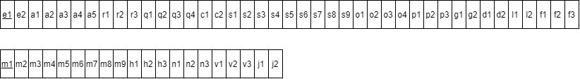

**2NF:** A relation in first normal form in which every non-key attribute is fully functionally dependent on the primary key.

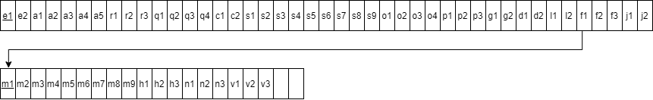

**3NF:** A relation that is in second normal form and has no transitive dependencies.

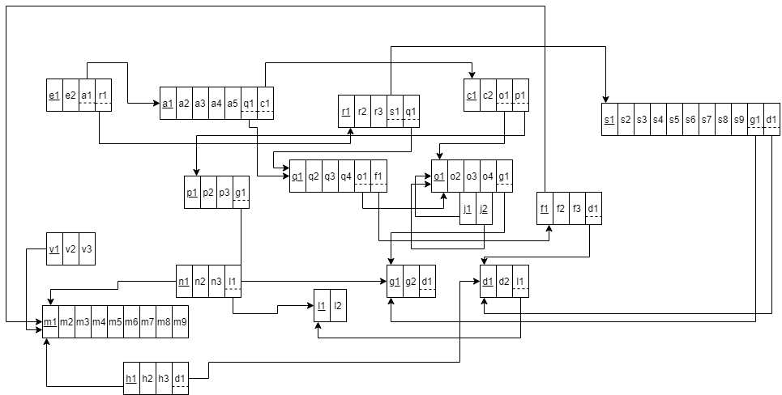

**BCNF:** All determinants are candidate keys. There is no determinant that is not a unique identifier. Here, all the relations already are in BCNF.

# 3.6 DATA DICTIONARY:

**School_T**

|  |  |  |  |
| --- | --- | --- | --- |
| Name | Data Type | Size | Remarks |
| cSchoolID | VARCHAR | 5 | This is the primary key of School.  E.g: “SETS” |
| cSchoolName | VARCHAR | 50 | This is the name of the School.  E.g: “School of Engineering, Technology & Science”. |

**Program_T**

|  |  |  |  |
| --- | --- | --- | --- |
| Name | Data Type | Size | Remarks |
| cProgramID | INTEGER |  | This is the primary key for a program.  E.g: “1” |
| cProgramName | VARCHAR | 50 | This is the name of the program.  E.g: “Bachelor of Science” |
| cDepartmentID | VARCHAR | 3 | This is the foreign key from the Department table.  E.g: “CSE” |

**Department_T**

|  |  |  |  |
| --- | --- | --- | --- |
| Name | Data Type | Size | Remarks |
| cDepartmentID | VARCHAR | 3 | This is the primary key for the Department table.  E.g: “CSE” |
| cDepartmentName | VARCHAR | 50 | This is the name of the department.  E.g: “Computer Science and Engineering”. |
| cSchoolID | VARCHAR | 5 | This is a foreign key from the School table.  E.g: “SETS”. |

**Student_T**

|  |  |  |  |
| --- | --- | --- | --- |
| Name | Data Type | Size | Remarks |
| nStudentID | INTEGER |  | This is the primary key for the Student table.  E.g: “1921834”. |
| cFirstName | VARCHAR | 30 | This is the first name of the student.  E.g: “Rakibul”. |
| cLastName | VARCHAR | 30 | This is the last name of the student.  E.g: “Hasan”. |
| dDateOfBirth | DATE | DD-MM-YYYY | This is the birth date of the student.  E.g: “21-12-1996”. |
| cGender | VARCHAR | 6 | This is the gender of the student.  E.g: “Female”. |
| cEmail | VARCHAR | 30 | This is the email of the student.  E.g: “1921834@iub.edu.bd” |
| nPhone | NUMERIC | 11 | This is the phone of the student.  E.g: “01XXXXXXXXX”. |
| cAddress | VARCHAR | 50 | This is the address of the student.  E.g: “House 1,Road 4,Block D, Bashundhara RA |
| cDepartmentID | VARCHAR | 3 | This is the foreign key from the Department table.  E.g: “CSE” |
| cProgramID | INTEGER |  | This is the foreign key from the Program table.  E.g: “1” |
| dEnrollmentDate | DATE | DD-MM-YYYY | This is enrollment date of the student.  E.g.: “1-1-2019” |

**CO_T**

|  |  |  |  |
| --- | --- | --- | --- |
| Name | Data Type | Size | Remarks |
| cCOID | VARCHAR | 9 | This is the primary key for the CO table.  E.g: “CO1”. |
| nCONum | INTEGER |  | This is the CO number.  E.g: 1,2 etc. |
| cCourseID | VARCHAR | 6 | This is the foreign key from the Course table.  E.g: “CSE303” |
| cPLOID | VARCHAR | 5 | This is the foreign key from the PLO table.  E.g: “PLO1” |

**PLO_T**

|  |  |  |  |
| --- | --- | --- | --- |
| Name | Datatype | Size | Remarks |
| cPLOID | VARCHAR | 5 | This is the primary key for Program Learning Outcome.  E.g: “PLO1” |
| nPLONum | INTEGER |  | This is the PLO number. E.g: “1” |
| cDetails | VARCHAR | 50 | This is the details for Program Learning Outcome.  E.g: “An ability to select and apply the knowledge, technique, skills and modern tools of the computer science and engineering discipline ” |
| cProgramID | INTEGER |  | This is a foreign key from Program table.  E.g: “1” |

F **Employee_T**

|  |  |  |  |
| --- | --- | --- | --- |
| Name | Datatype | Size | Remarks |
| nEmployeeID | INTEGER |  | This is the primary key for Employee table.  E.g: “1801” |
| cFirstName | VARCHAR | 30 | This is the first name of the faculty.  E.g: “Sadita” |
| cLastName | VARCHAR | 30 | This is the last name of the faculty.  E.g: “Ahmed” |
| dDateofbirth | DATE | DD-MM-YYYY | This is the date of Birth of the faculty.  E.g:01-01-1992 |
| cGender | VARCHAR | 6 | This is the gender of the faculty.  Eg: “Female” |
| cEmail | VARCHAR | 30 | This is the email address of the Student.  E.g: “1675231@iub.edu.bd” |
| nPhone | NUMERIC | 11 | This is the phone number of the Faculty.  E.g: “01292383111” |
| cAddress | VARCHAR | 30 | This is the address of the Faculty.  E.g: “House 14, Road 21, Sector 11,Baridara,Dhaka, Bangladesh” |
| cEmployeeType | CHAR | 1 | This is the type of the employee.  E.g: “F” |

**Course_T**

|  |  |  |  |
| --- | --- | --- | --- |
| Name | Datatype | Size | Remarks |
| cCourseID | VARCHAR | 6 | This is the Primary Key for the Course. E.g: “CSE203” |
| cCourseName | VARCHAR | 40 | This is the name of the Course.  E.g: “Discreet Mathematics” |
| nNumOfCredits | INTEGER |  | This is the number of credits for the Course.  E.g: “3” |
| cCourseType | VARCHAR | 10 | This is the type of the Course. E.g: “Core” |
| cProgramID | INTEGER |  | This is the foreign key from the program table.  E.g: “1” |

**Section_T**

|  |  |  |  |
| --- | --- | --- | --- |
| Name | Datatype | Size | Remarks |
| nSectionID | INTEGER |  | This is the Primary Key for Section.  E.g: “1” |
| nSectionNum | INTEGER |  | This is the section number.  E.g: “1” |
| cCourseID | VARCHAR | 6 | This is the foreign key from the Course table.  E.g: “CSE101” |
| cFacultyID | NUMERIC | 4 | This is the foreign key from Faculty table.  E.g: “1801” |
| cSemester | VARCHAR | 6 | This is the semester of the section.  E.g: “Summer” |

**Registration_T**

|  |  |  |  |
| --- | --- | --- | --- |
| Name | Datatype | Size | Remarks |
| nRegistrationID | INTEGER |  | This is the Primary Key for Registration.  E.g: “0101010101” |
| cSemester | VARCHAR | 6 | This is the semester of registration.  E.g: “Spring” |
| dYear | YEAR | yyyy | This is the year of registration.  E.g: “2019” |
| nSectionID | INTEGER |  | This is the Foreign Key from Section table  E.g: “1” |
| nStudentID | INTEGER |  | This is the Foreign key from the Student Table.  E.g: “1800001” |

**Assessment_T**

|  |  |  |  |
| --- | --- | --- | --- |
| Name | Datatype | Size | Remarks |
| nAssessmentID | INTEGER |  | This is the Primary Key for Assessment. |
| cAssessmentName | VARCHAR | 30 | This is the name of the assessment.  E.g: “Mid” |
| cTotalMarks | NUMBER |  | This is the total marks of the assessment.  E.g: “30” |
| nSectionID | INTEGER |  | This is the Foreign Key from Section table. |
| nCOID | INTEGER |  | This is the Foreign Key from the Course Outcome table. |
| nQuestionNum | INTEGER |  | This is the question number for assessment.  E.g: “1,2,3….” |
| nWeight | INTEGER |  | This is the percentage range for assessment.  E.g: “Project- 50%, Assessment-50%”. |

**Evaluation_T**

|  |  |  |  |
| --- | --- | --- | --- |
| Name | Datatype | Size | Remarks |
| nEvaluationID | INTEGER |  | This is the Primary Key for Enrollment. |
| cObtainedMarks | NUMBER |  | This is the obtained marks of the student.  E.g: “24.5” |
| cAssessmentID | INTEGER |  | This is the foreign key from the assessment table. |
| nRegistrationID | INTEGER |  | This is the Foreign Key from Registration table. |

**VC_T**

|  |  |  |  |
| --- | --- | --- | --- |
| Name | Datatype | Size | Remarks |
| nVEmployeeID | INTEGER |  | This is the foreign key from the Employee table. E.g: “4250” |
| dStartDate | DATE | dd-mm-yyyy | This is starting date for the VC. E.g: “01-03-2020” |
| dEndDate | DATE | dd-mm-yyyy | This is the date VC retire from his post. E.g: “01-03-2024” |

**DEAN_T**

|  |  |  |  |
| --- | --- | --- | --- |
| Name | Datatype | Size | Remarks |
| nDEmployeeID | INTEGER |  | This is the foreign key from the Employee table.  E.g: “4250” |
| cSchoolID | VARCHAR | 5 | This is the SchoolID of the school DEAN manages.  E.g: “SETS” |
| dStartDate | DATE | dd-mm-yyyy | This is starting date.  E.g: “01-03-2020” |
| dEndDate | DATE | dd-mm-yyyy | This is the date DEAN retire from his post. E.g: “01-03-2024” |

**DEPARTMENTHEAD_T**

|  |  |  |  |
| --- | --- | --- | --- |
| Name | Datatype | Size | Remarks |
| nHEmployeeID | INTEGER |  | This is the foreign key from the Employee table.  E.g: “4250” |
| cDepartmentID | VARCHAR | 3 | This is the DepartmentID of the department HEAD manages.  E.g: “CSE” |
| dStartDate | DATE | dd-mm-yyyy | This is starting date.  E.g: “01-03-2020” |
| dEndDate | DATE | dd-mm-yyyy | This is the date HEAD retire from his post. E.g: “01-03-2024” |

**Faculty_T**

|  |  |  |  |
| --- | --- | --- | --- |
| Name | Datatype | Size | Remarks |
| nFacultyID | INTEGER |  | This is the foreign key from the Employee table.  E.g: “4250” |
| cDepartmentID | VARCHAR | 3 | This is the DepartmentID of the department faculty belongs to.  E.g: “CSE” |
| dJoinDate | DATE | dd-mm-yyyy | This is starting date.  E.g: “01-03-2020” |
| cRank | VARCHAR | 30 | This is the rank of the faculty.  E.g: “Assistant Professor” |

**PreReqCourse_T**

|  |  |  |  |
| --- | --- | --- | --- |
| Name | Datatype | Size | Remarks |
| cCourseID | VARCHAR | 6 | This is the foreign key from the Course table. E.g: “CSE303” |
| cPreReqCourseID | VARCHAR | 6 | This is the foreign key from the Course table .  E.g: CSE203 |